Flow Chart:

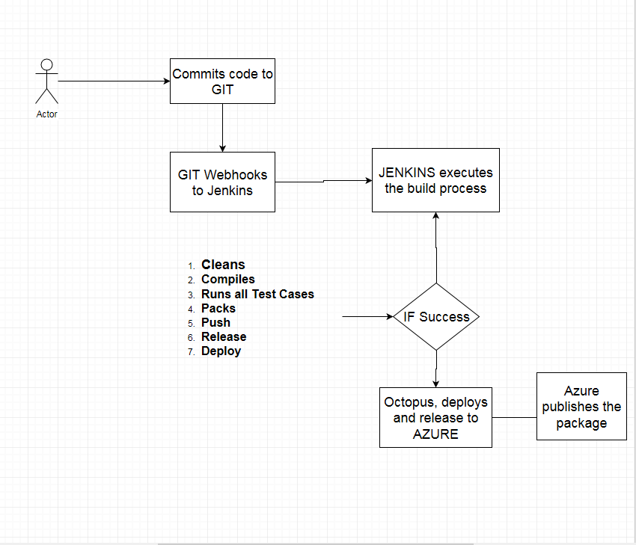

API Key

Scripts can access Octopus deploy and deploy services

Azure Service Principal

Octopus Deploy can deploy applications to Azure

QA Environment

Build User as a service account, so that never logon using API Keys

**API-JTBAGTU6EYLKLHA57BBPVMXFYQ**

Octopus Deploy and Azure

Azure

Application url <http://octopusdeploy-csitaram.net>

Deployment Steps

1. Create a Project
2. Add Step, Deploy An Azue Web App

Link up

1. Push the package to Octopus Deploy
2. Create Release
3. Deploy of the release.

Azure:

Blue Green Deployment

Two slots, and swap

1. Create a staging slot in Azure
2. Deploy to staging slot
3. Swap slots after deploy
4. Smoke Tests
5. Reusable build script
6. Acceptance Test

Jenkins:

Point to git server, and runs the build

Smoke test script

$environment = $OctopusParameters["Octopus.Environment.Name"]

$project = $OctopusParameters["Octopus.Project.Name"]

$uri = "http://$environment-$project-staging-azurewebsites.net"

$expectedStatusCode = 200

Write-Host "Making request for $url"

$response = Invoke-WebRequest -UseBasicParsing $url -MaximumRedirection 1

$statusCode = [int]$response.StatusCode

if($statusCode -ne $expectedStatusCode) {

throw "Smoke test failed for " + $url

}

Deploy staging -> Smoke Stage ->Swap SLots